**LAB # 09**

**Broadcast Receiver – DebugConsole**

1. **Create an application named DebugConsole having the following UI:**

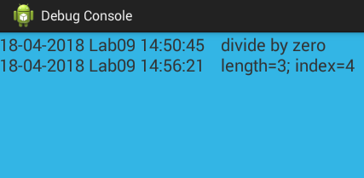

* Main purpose of this application is to display exceptions occurred in other user applications through broadcast receiver.
* This application must register a custom broadcast receiver having DEBUG_INFO action. On receiving that broadcast it must obtain timestamp, application name from the associated intent.
* Other applications must send their app name and a message while timestamp must be managed by this application.
* Note that the UI contains only one TextView component having light blue background color with black text.
* The text must be scrollable by user. You may use setMovementMethod(new ScrollingMovementMethod) to set the scrolling of TextView.

1. **Create an application which can send broadcast to the DebugConsole (above application). You may use the following UI as reference:**

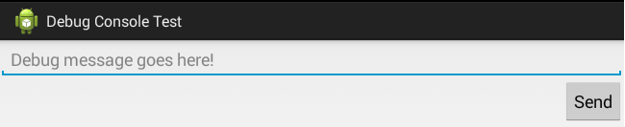

* On pressing send button a broadcast with action DEBUG_INFO must be send to the system. That broadcast must contain application name as well as message, given by user, to be displayed on DebugConsole.